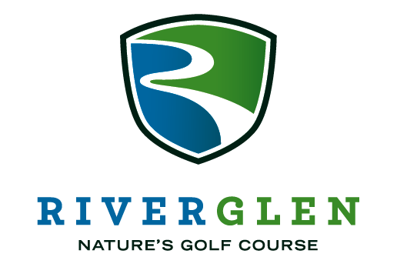
2023 FHS Penske Honda Golf Outing
Thursday, July 20th 2023 – River Glen Country Club
Registration opens at 11:30am
Shotgun start at 1:00pm
Player Registration Form
Make check payable to “FHS Gridiron Club”
Player 1 ____________________ Email ___________________Shirt Size____ Address __________________________ City ____________ State ___ Zip ______ Player 2 ____________________ Email ____________________Shirt Size_________ Address __________________________ City ____________ State ___ Zip ______ Player 3 ____________________ Email ____________________Shirt Size_________ Address __________________________ City ____________ State ___ Zip ______ Player 4 ____________________ Email _________________Shirt Size _______ Address __________________________ City ____________ State ___ Zip ______
EARLY BIRD REGISTRATION!
Register by June 1st and you will receive a Free Mulligan Package!
Foursome $500
Individual $145
FHS Football Player $85

Register online or mail to:
Fishers Gridiron Club
PO Box 527
Fishers, IN 46038

2023 FHS Penske Honda Golf Outing
Thursday, July 20th 2023 – River Glen Country Club
supporting the Fishers Football program
Sponsorship Form
I would like to sponsor the following:
___ Title Sponsor* ($3500) SOLD
___ Hole Sponsor ($500)
___ Dinner Sponsor* ($2600)
___ Lunch Sponsor* ($2400)
___ Beverage Cart Sponsor ($2000)
___ Putting green Sponsor ($125)
___ Range Sponsor ($100)
___ I cannot attend but I want to donate with a gift of $ ______
*sponsorship level includes Category Exclusivity
Checks made payable to “FHS Gridiron Club”
FHS Gridiron Club is a non-profit 501(c)(3) football booster group
Contact/Company Information
Family/Company Name _______________________________________________ Primary Contact & Title _______________________________________________ Address __________________________ City ____________ State ___ Zip ______ Email ________________________________________ Phone ________________
Register online or mail form and check to:
Fishers Gridiron Club, PO Box 572, Fishers, IN 46038
2023 FHS Penske Honda Golf Outing
supporting the Fishers Football program
Sponsorship Opportunities
Title Sponsor (1): $3500 SOLD
- This sponsor will have the naming rights for the golf outing, banner at the registration tent/booth, and host of the registration tent. Logo on printed home programs, logo placement on a T-shirt for our two special event games, framed team poster to hang in your business, and recognition on our social media platforms. Additionally, we will acknowledge your sponsorship verbally before and after the golf outing. Title Sponsor also includes a foursome.
Dinner Sponsor (1): $2600
- This sponsorship will be recognized verbally at dinner, with signage and a banner at Dinner. Logo on printed home programs, logo placement on a T-shirt for our two special event games, framed team poster to hang in your business, and recognition on our social media platforms. Additionally, we will acknowledge your sponsorship verbally before and after the golf outing. Tent/booth by the clubhouse. Dinner Sponsor also includes a foursome.
Lunch Sponsor (1): $2400
- This sponsorship will be recognized verbally at lunch, with signage and a banner at lunch. Logo on printed home programs, logo placement on a T-shirt for our two special event games, framed team poster to hang in your business, and recognition on our social media platforms. Additionally, we will acknowledge your sponsorship verbally before and after the golf outing. Tent/booth by the clubhouse. Lunch Sponsor also includes a foursome.
Beverage Cart Sponsor (2): $2000
- This sponsorship will have signage on the cart, a tent/booth by the clubhouse, and verbal acknowledgment of sponsorship before and after the golf outing. Logo on printed home programs, logo placement on a T-shirt for our two special event games, framed team poster to hang in your business, and recognition on our social media platforms.
Hole Sponsor (18): $500
- With this sponsorship, you will get a yard sign on a specific hole and you can set up your own tent/booth to interact with the golfers. Framed team poster to hang in your business and recognition on our social media platforms.
Putting Green Sponsorship: $125
- Sponsorship includes a yard sign.
Range Sponsorship: $100
- Sponsorship includes a smaller yard sign.
Golf foursome: $500 Individual golfer: $145
- Includes lunch, dinner, golfing fees, cart, and drinks on the course.

